**HAPPY EARLY LEARNING Philosophy reflections and development 2020**

January 2020 our team begun to think about the development of our own philosophy that was meaningful to our children, families, and Educators.

We first thought why we need our own philosophy, why is it important, how do we contextualise what we do in keeping with the overarching Early Learning pedagogy.

Our current philosophy aligns with the guiding principles of the NQF:

* The rights of the child are paramount.
  + Children regardless of gender, race, physical ability, or socioeconomic background deserve the right to grow and develop
* Children are successful, competent, and capable learners.
  + Each child is viewed holistic manner and individual needs and interest are shared and built upon to ensure positive learning experiences for every child.
  + Children learn through play; therefore, we will encourage and support their learning and development by being involved, supportive and available.
  + We believe every child can learn and therefore we will develop strong, nurturing and respectful relationships so that they feel confident to take on challenges and secure enough to make friends and learn the world in which they live.
  + We want to nurture children in a sense of wonder and appreciation for the environment through providing a variety of experiences for them to choose and explore at their own pace.
* Equity, inclusion, and diversity underpin the framework.
  + We value each child’s unique culture and celebrate diversity.
* Australia’s Aboriginal and Torres Strait Islander cultures are valued.
* The role of parents and families is respected and supported.
  + Educators work in partnership with family members and the community,
  + We encourage and welcome family’s participation in the program, open communication and sharing of information
* Best practice is expected in the provision of education and care services.
  + Our educators will be motivated and dedicated professionals who will participate in professional development opportunities to ensure the quality practices is maintained as part of our continuous improvement plan.

Therefore, a solid start to thinking how our practices align with these principles.

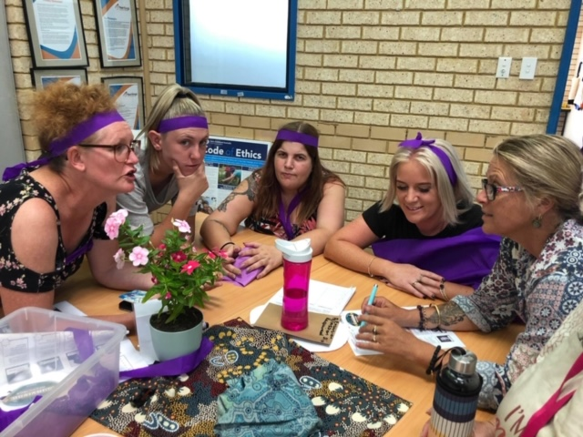**Our Reflections:**

During February 2020 we discussed the EYLF and how it influences our practices. We developed questions for our children and families to inform which principles and practices we should celebrate and acknowledge within our philosophy, and what they would like us to do differently.

Some of the responses were:

1. How to you feel we provide secure and respectful relationships with your children.

We pride ourselves on developing loving nurturing relationships with children so that they feel safe and confident to explore their environment and secure enough to begin developing friendships.

We believe supporting children in their growing awareness and interest in animals can lead to deeper feelings of empathy, more positive relationships, and social-emotional development.  As children have experiences with animals, they learn about differences and similarities, needs (such as for food, shelter, water, and space), and compassion and empathy can grow and deepen.

Children shared with us:

My friends and the chickens

Friends I play with

The Teachers

Educators

(make us feel safe)

1. What do you think we do to respect the diversity of your family?

Families shared they liked how we shared Aboriginal culture and language into their children’s day.

Our families believe our relationships with them is strong and they feel respected during discussions about their child and cultural inclusion of their family’s values and beliefs.

1. How are we responsive to your child?

Implementation of routines and activities that assist children to develop a sense of belonging e.g. photo wall, cultural inclusions, interest based.

We want to be a place that is special and unique to the children and families. We often hear how excited children are to come. Families and children never rush out they linger to chat and say goodbye. This reflects how attachments are fostered here and how each person develops a sense of belonging. The ELP children are involved in all other activities going on at the service to also foster a sense of place.

School readiness focus children told us they wanted to write more words and read outside. They like routine tasks like packing away, putting their bags away, choosing art experiences to engage in, physical activity games and singing times.

1. How are our environments inclusive and welcoming?

Families recognised that greeting each family and child by their name made them feel acknowledged and welcomed.

Educators understand that all children are different when they arrive, some need time to settle themselves, others like to engage with other straight away, if is supported and respected.

In March 2020 we discussed theorists that lead our practices. Malaguzzi, Bronfenbrenner and Bowlby.

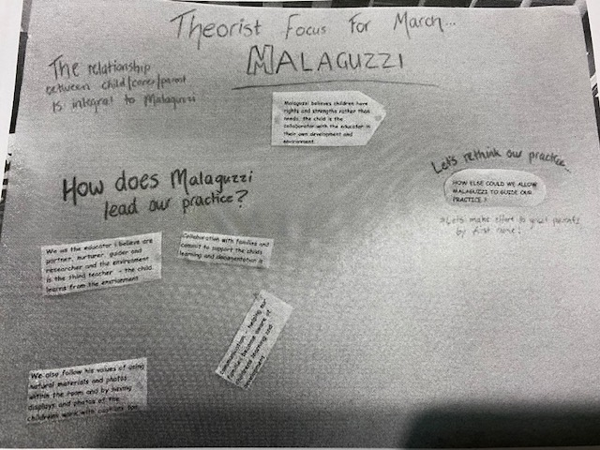Educators' work is influenced by their knowledge, so it is essential for educators to understand the best of contemporary knowledge about how children learn. This helps to ensure that the way educators work is not just based on traditional approaches or the way educators have always worked.

As a team we identified the below current practices we implement that align with these theories:

**Malaguzzi:**

The child is the collaborator with the educator in their own development and environment.

Collaboration with families and children is important

Documentation is our communication to families and makes them aware of children learning and development.

Children are reflectors too, create opportunities for children to evaluate practice, compare, negotiate and problem solve together.

**Bowlby:**

Our long-term Educators have developed a strong relationship within the community.

Our Educators are a strong secure base for our children, they transition well in the mornings and throughout the day are confident to explore their environment with confidence.

**Bronfenbrenner:**

We support families to be strong and confident in their parenting and learning about development.

We acknowledge children for where they are in their development.

We welcome families and community into our service to extend the connection with community.

Create a culturally safe space for children and families

**What we learnt:**

From these reflections with Educators, children, and families over the last few months we developed our big statements- What we do well.

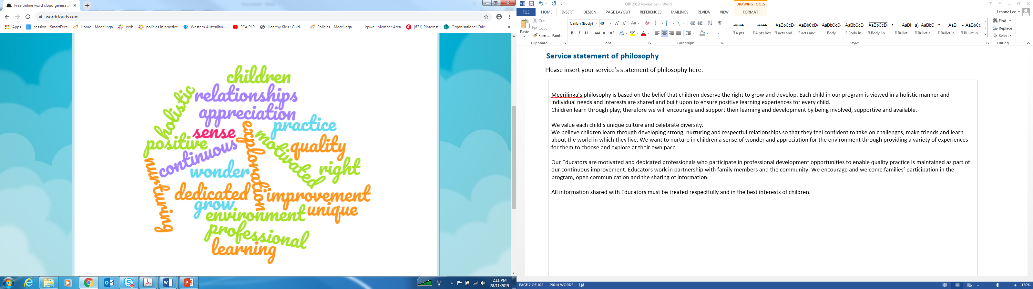

In April 2020nmwe then reflected on these big statements and discussed what this looks like in practice.

|  |  |
| --- | --- |
| **Philosophy Statement** | **Practice** |
| Nurturing and respectful relationships | Recognise children’s identity  Respect their right to make decisions about play  Educators and peers are caring empathic and solution focused to problems  Each Educator has responsibility for specific children for observations, communication with families and built strongest connections with the child  Core staff which provides a stable environment for children  Showing warm and welcoming behaviours  Humour  Building on strengthens and interests  Identifying feelings  Educators are accessible and have a genuine interest in watching and listening with children.  Identifying the environment supports or triggers children behaviour.  Support emotional wellbeing |
| Appreciation for the environment | Providing beautiful environments for children to engage in play and socialization  Children are taught respect for the environment, land, animals  Growing plants  Respecting our pets and their home  Engage with community to share our appreciation of Earth. |
| Dedicated professionals | Research  Language and culture learning  Critical reflection |
| Partnership with family members and the community. | RAP engagement and planning.  Policy reviews  Curriculum feedback  Provide a home like environment to provide connection  Parents strengths to engage with children interests and intentional teaching. |
| We believe every child learns differently so we endeavour to work to each child’s strengths and educate through play and interests | Intentional teaching  Learning through play program development  Respect the Voice of the Child  Providing opportunities for children to share their visions and interests therefore providing a confident learning environment |

In May 2020 we discussed key points and actions of the philosophy. During this critical reflection discussion, we identified the below core concepts and discussed how these concepts aligned with professional practice:

* Importance of children learning through play, staff are setting the room up for the children to explore, grow and develop, holistic manner (NQS 1.1, 1.2, 1.3, 4.1, 5.2)
* All staff building good relationships with children and families, partnership with the community including cultural events. (5.1, 5.2, 6.1, 6.2)
* Provide children with experiences, they have identified, hearing their voice, ensuring they are engaged and happy. (1.1, 1.2, 1.3, 5.1, 5.2)
* We accept and believe all children regardless of gender, race physical ability deserves the right to grow and develop. (1.1, 1.2, 1.3, 5.1, 5.2, 6.2)
* Each child is viewed in a holistic way. A strong part of viewing each child in a holistic way is that all Educators have strong relationship with families and working in collaboration with them. (1.1, 1.2, 1.3, 5.1, 5.2, 6.1, 6.2)

From the 5 months of reflections our staff were then asked to develop a series of statements that will be our Philosophy, they aligned with the collated responses from families, children, staff knowledge and reflected on the theorists that are the foundation of our practices.

In July 2020, our new statement was launched

**We Value**

|  |  |  |  |  |
| --- | --- | --- | --- | --- |
| **Activity** | **Rating and Assessment** | | | |
| Element 7.1.1 | Service philosophy and purpose A statement of philosophy guides all aspects of the service’s operations. | | | |
| 1. Assess this element as ‘met’ or ‘not met’ Assess each element as ‘met’ or ‘not met’ and determine compliance with the relevant regulations. | Significant Improvement Required (S) | Working Towards national Quality Standard (W) | Meeting National Quality Standard (M) | Exceeding national Quality Standard (E) |
| 2. Rate the element using the service story | A Significant Improvement Required rating may be given for a standard and/or quality area. | Service does not meet one or more elements or relevant regulations for the standard. The service does not meet the standard. | All elements and relevant regulations for the standard are 'met'. The service does not demonstrate the three Exceeding themes for the standard. The standard is rated Meeting NQS | All elements and relevant regulations for the standard are 'met'. The service demonstrates the three Exceeding themes for the standard: 1. Practice is embedded in service operations 2. Practice is informed by critical reflection 3. Practice is shaped by meaningful engagement with families and/or the community. The standard is rated Exceeding NQS. |
| List why you have selected this rating |  |  |  |  |